**Name: Imon Raj**

**Roll: 002010501098**

**Dept: CSE**

**Year: Second**

-------------------------------------------------------------------------------------------

**Problem Statement: Given two polygons, say pentagons, find out whether they intersect or not**

**Solution Approach:**

We will create following type of structures –

* Point
* Line
* Polygon

Each Point will consist two co-ordinates in float. Each Line consists of two Points. Each Polygon will have count of total points and array of all its lines.

We will take the two polygons’ Points as user input and internally we will create array of Lines which will be basically stored in the Polygon structure. Using these Lines we will determine whether two Polygons intersect or not. We will have some functions to do our job –

* create_point
* create_line
* create_polygon
* take_points
* equal_slope
* infinite_slope
* line_intersect
* polygon_intersect

Now, basically two Polygons intersect means at least one pair of lines of them intersects. To determine whether two Lines intersect or not –

* If the slope of both lines are infinite we will say equal slopes means not intersect – possibly parallel or touch but not intersect
* One slope infinite another finite means unequal slopes – may intersect
* both slopes finite and equal don’t intersect
* finite and non-equal – may intersect

Now, geometrically two lines with different slope surely intersect but this is actually taking the fact that straight line is infinite and can be extended.

**By Geometrical intersection point I want to mean the intersection point of two infinite length Lines.**

But for our question intersecting lines means the geometrically intersecting point must be within the range or length of both the lines. That means the x-coordinate of the geometrical intersection must be between the x values of two points of two finite length lines.

To find the geometrical intersecting point’s X-co-ordinate-

final_X = (b1c2 – b2c1)/(a1b2 – a2b1);

where Lines equations are – a1x + b1y + c1 = 0;

a2x + b2y + c2 = 0;

Line equations and with that the value of a1,a2.. etc can be calculated using the end points of lines.

I will show an image to make sense how intersecting lines, parallel lines and non-intersecting lines look in case of finite length lines.

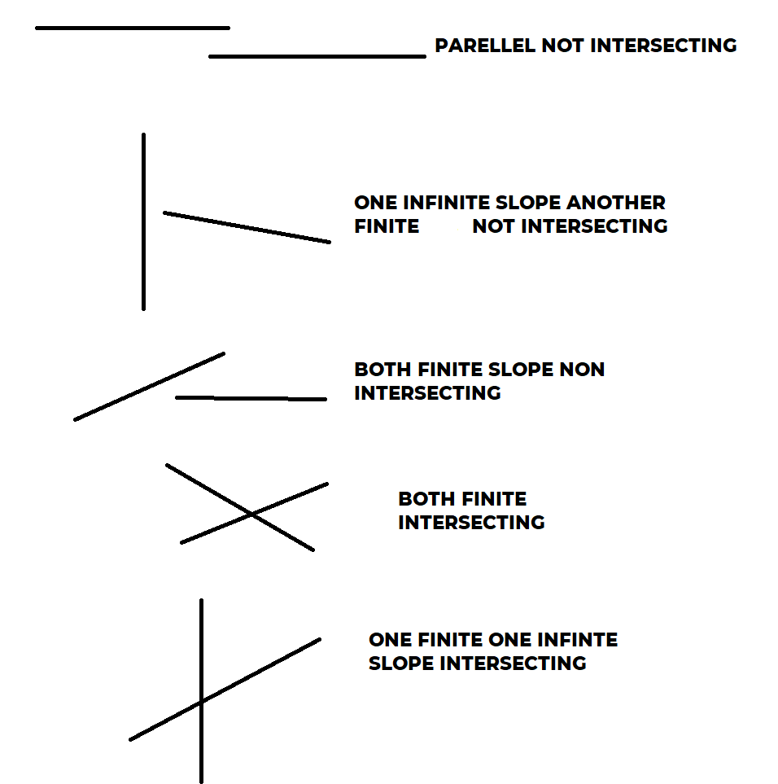

**Algorithm:**

TO CHECK IF TWO LINES INTERSECT:

Firstly, find the geometrical intersection point’s X value as final_X using the above-mentioned formula.

Secondly, check if x1 < final_X < x2 and x3 < final_X < x4 (x1,x2,x3,x4 are four x values of two lines’ end points), that means the geometrical intersection point lie on the lines. If that is true, then two finite length lines intersect.

TO CHECK IF POLYNOMIAL INTERSECT:

I will run two nested for loops to check intersection situation of each Line of first polynomial to each Line of second polynomial. If even in a single case one line of 1st polynomial intersect with any line of 2nd polynomial, then I will return true, means polynomials intersect each other. But after the loops end, we will return false, because in that case loops can’t find any single pair of intersecting Lines.

**Results:**

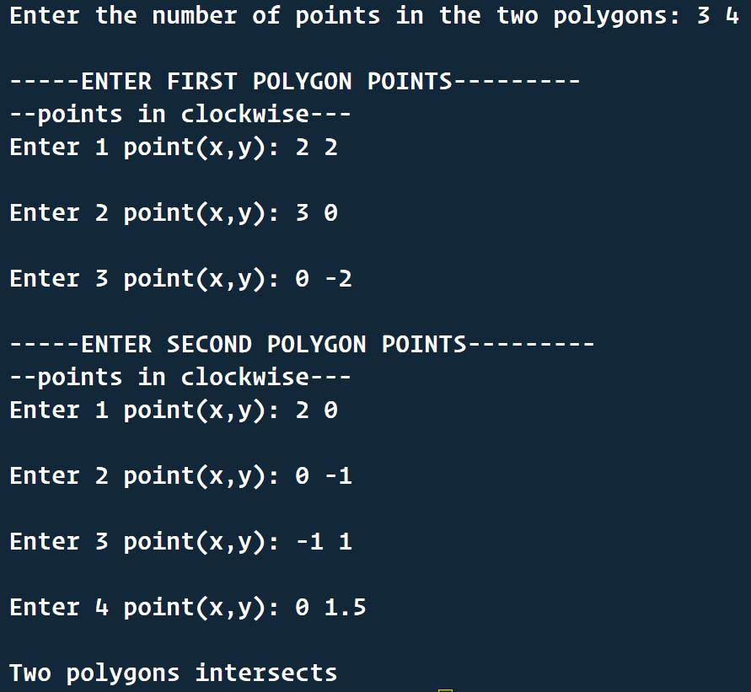

**Discussion:**

During the program writing, we must be careful for infinite slope because that creates divide by zero. While creating Lines from Points we need to create them in one order maybe clockwise of anti-clockwise. To be remembered, last Line will have last point and first point as end points.